**E-COMMERCE REPORT QUERY DOCUMENT**

**Dashboard:**

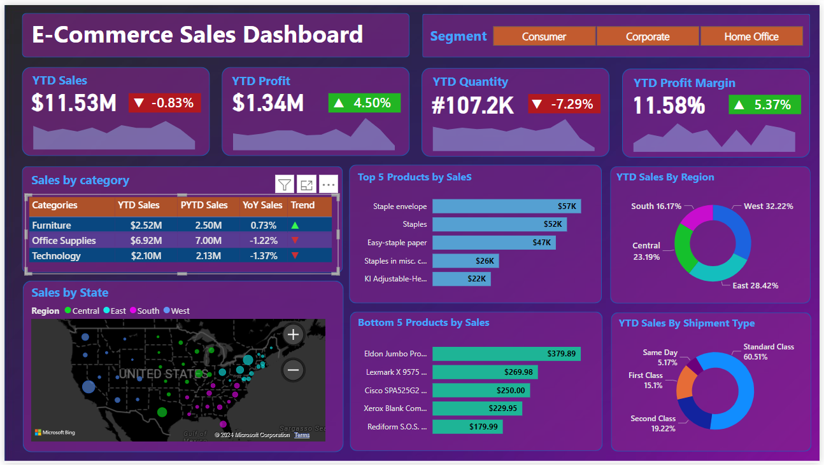

**KPI’s:**

**YTD Sales:**

select ROUND(SUM(sales_per_order),2) as Sales_YTD from sales_data where YEAR(order_date)='2022';

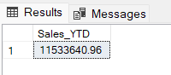

**PYTD Sales:**

select ROUND(SUM(sales_per_order),2) as Sales_PYTD from sales_data where YEAR(order_date) != '2022'

**YoY Sales Growth:**

with YTD_Sales as

(select SUM(sales_per_order) as Sales_YTD from sales_data where YEAR(order_date)='2022'),

PYTD_Sales as

(select SUM(sales_per_order) as Sales_PYTD from sales_data where YEAR(order_date) != '2022')

SELECT ROUND(100*(Sales_YTD - Sales_PYTD)/Sales_PYTD,2) from YTD_Sales,PYTD_Sales;

**YTD Profit:**

select ROUND(SUM(profit_per_order),2) as Profit_YTD from sales_data where YEAR(order_date)='2022';

**PYTD Profit:**

select ROUND(SUM(profit_per_order),2) as Profit_PYTD from sales_data where YEAR(order_date)!='2022';

**YoY Profit Growth:**

with YTD_Profit as

(SELECT SUM(profit_per_order) as Profit_YTD from sales_data where YEAR(order_date)='2022'),

PYTD_Profit as

(SELECT SUM(profit_per_order) as Profit_PYTD from sales_data where YEAR(order_date)!='2022')

SELECT ROUND(100*(Profit_YTD-Profit_PYTD)/Profit_PYTD,2) from YTD_Profit,PYTD_Profit;



**YTD Quantity:**

select ROUND(SUM(order_quantity),2) as Quantity_YTD from sales_data where YEAR(order_date) = '2022';

**PYTD Quantity:**

select ROUND(SUM(order_quantity),2) as Quantity_PYTD from sales_data where YEAR(order_date) != '2022';

**YoY Quantity Growth:**

with YTD_Quantity as

(select SUM(order_quantity) as Quantity_YTD from sales_data where YEAR(order_date) = '2022'),

PYTD_Quantity as

(select SUM(order_quantity) as Quantity_PYTD from sales_data where YEAR(order_date) != '2022')

SELECT ROUND(100.0*(Quantity_YTD-Quantity_PYTD)/Quantity_PYTD,2) from YTD_Quantity,PYTD_Quantity;

**YTD Profit Margin:**

select ROUND(100*(SUM(profit_per_order))/SUM(sales_per_order),2) as Profit_Margin_YTD from sales_data where YEAR(order_date)='2022';

**PYTD Profit Margin:**

select ROUND(100*(SUM(profit_per_order))/SUM(sales_per_order),2) as Profit_Margin_PYTD from sales_data where YEAR(order_date)!='2022';

**YoY Profit Margin Growth:**

with YTD_Profit_Margin as

(select ROUND(100*(SUM(profit_per_order))/SUM(sales_per_order),2) as Profit_Margin_YTD from sales_data where YEAR(order_date)='2022'),

PYTD_Profit_Margin as

(select ROUND(100*(SUM(profit_per_order))/SUM(sales_per_order),2) as Profit_Margin_PYTD from sales_data where YEAR(order_date)!='2022')

SELECT ROUND(100.0*(Profit_Margin_YTD-Profit_Margin_PYTD)/Profit_Margin_PYTD,2) from YTD_Profit_Margin,PYTD_Profit_Margin;

**Sales by Categories:**

select category_name,ROUND(SUM(sales_per_order),2) as YTD_Sales_by_category from sales_data where YEAR(order_date)='2022' group by category_name ;

select category_name,ROUND(SUM(sales_per_order),2) as PYTD_Sales_by_category from sales_data where YEAR(order_date)!='2022' group by category_name ;

with Category_YTD_Sales as

(select category_name,ROUND(SUM(sales_per_order),2) as YTD_Sales_by_category from sales_data where YEAR(order_date)='2022' group by category_name ),

Category_PYTD_Sales as

(select category_name,ROUND(SUM(sales_per_order),2) as PYTD_Sales_by_category from sales_data where YEAR(order_date)!='2022' group by category_name)

SELECT y.category_name,ROUND(100*(YTD_Sales_by_category-PYTD_Sales_by_category)/PYTD_Sales_by_category,2) as YoY_Growth from Category_YTD_Sales y

join

Category_PYTD_Sales p

on y.category_name = p.category_name ;

**Top 5 Products by Sales:**

select Top 5 product_name,ROUND(sum(sales_per_order),2) as YTD_Sales from sales_data where YEAR(order_date) ='2022' group by product_name order by YTD_Sales DESC;

**Bottom 5 Products by Sales:**

select Top 5 product_name,ROUND(sum(sales_per_order),2) as YTD_Sales from sales_data where YEAR(order_date) ='2022' group by product_name order by YTD_Sales;

**YTD Sales by Region:**

DECLARE @total_sales_region DECIMAL(12,2);

select @total_sales_region = SUM(sales_per_order) from sales_data where YEAR(order_date)='2022';

select customer_region,ROUND(100*SUM(sales_per_order)/@total_sales_region,2) as YTD_Sales from sales_data where YEAR(order_date)='2022' group by customer_region;

**YTD Sales by Shipment:**

DECLARE @total_sales_shipment DECIMAL(12,2);

select @total_sales_shipment = SUM(sales_per_order) from sales_data where YEAR(order_date)='2022';

select shipping_type,ROUND(100*SUM(sales_per_order)/@total_sales_shipment,2) as YTD_Sales from sales_data where YEAR(order_date)='2022' group by shipping_type;

**Filtered Data Queries:**

**YTD Sales in March:**

select ROUND(SUM(sales_per_order),2) as March_YTD_Sales from sales_data where YEAR(order_date)='2022' and MONTH(order_date)=3;

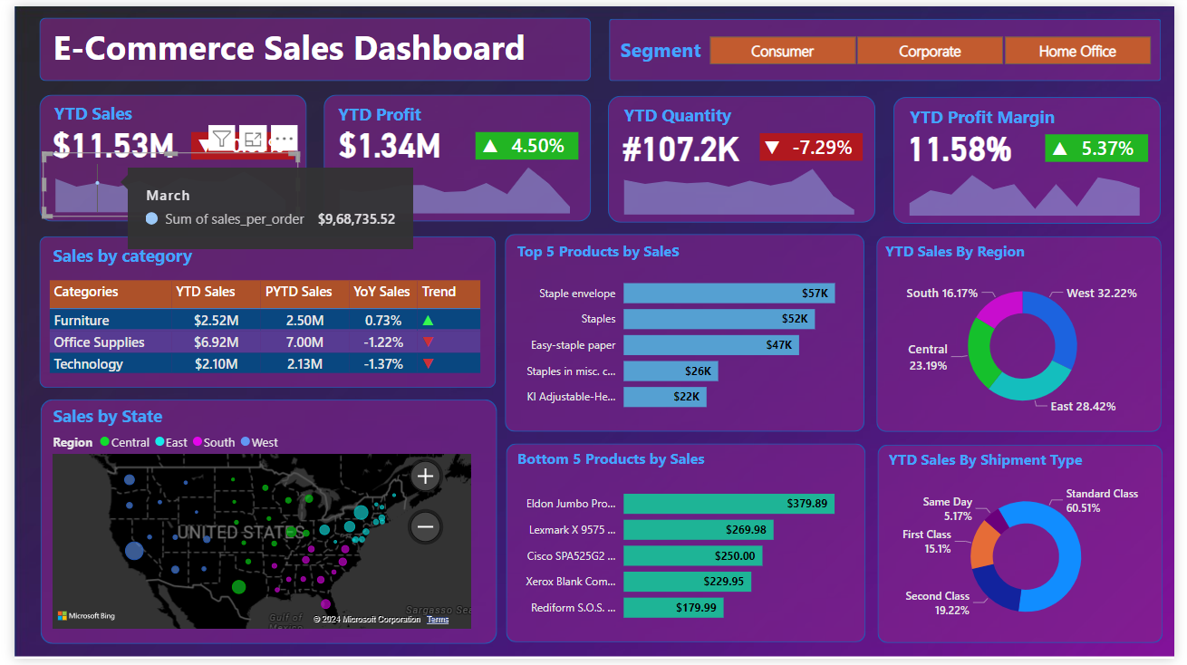

**South Region Furniture Sales YTD:**

select ROUND(SUM(sales_per_order),2) as YTD_Furniture_Sales_South from sales_data where YEAR(order_date)='2022'

group by customer_region,category_name

having customer_region='South' and category_name = 'Furniture';

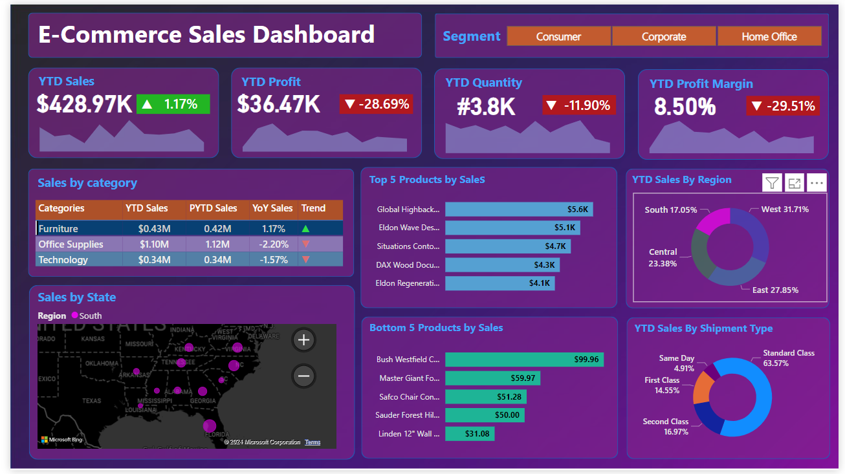

**Corporate Segment in East Region Top 5 products by YTD Sales:**

select Top 5 product_name,ROUND(SUM(sales_per_order),2) as YTD_Sales from sales_data

where YEAR(order_date)='2022'

group by product_name,customer_segment,customer_region

having customer_segment='Corporate' and customer_region ='East'

order by YTD_Sales desc;

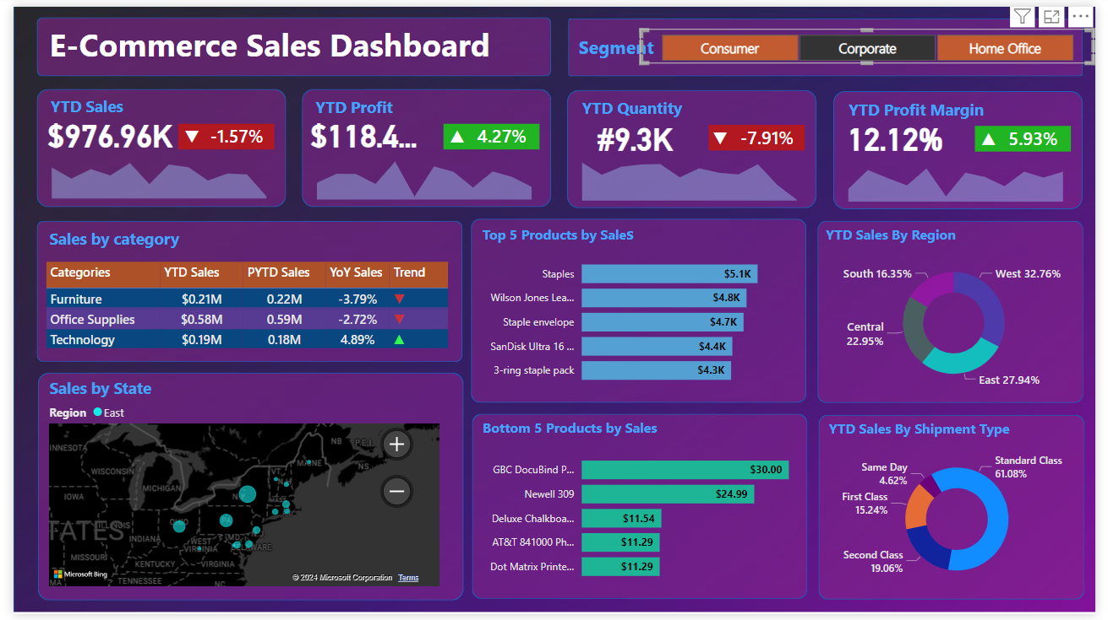

**Thank You for Reading**

**Regards**

**Dhruvik Detroja**